**ABSTRACT:**

Structured Query Language (SQL) is used to communicate with Relational Database Management Systems like, MySQL, Oracle, and PostgreSQL.

In SQL There are different types of queries to handle the data inside the relations (Tables).The SQL also has the inbuilt methods that makes it easier to perform some complicated operations like pattern matching.

This game is designed in such a way that most of the queries in SQL will be covered while playing the game it would be a best practice for beginners in SQL to learn in an Entertaining way.

**Base Story of the game:**

The Player is Given a Crime report by a Detective and lost it somehow all the player remembers is that the report is about a robbery happened on 24/04/2023 in Anna Nagar. Based on this information the user should start the interrogation by referring to the different tables are provided in the database.

**TABLES IN THE DATABASE:**

1. Crime Scene Table:

This table contains all the data about the crimes that happened in different cities and the descriptions about them.

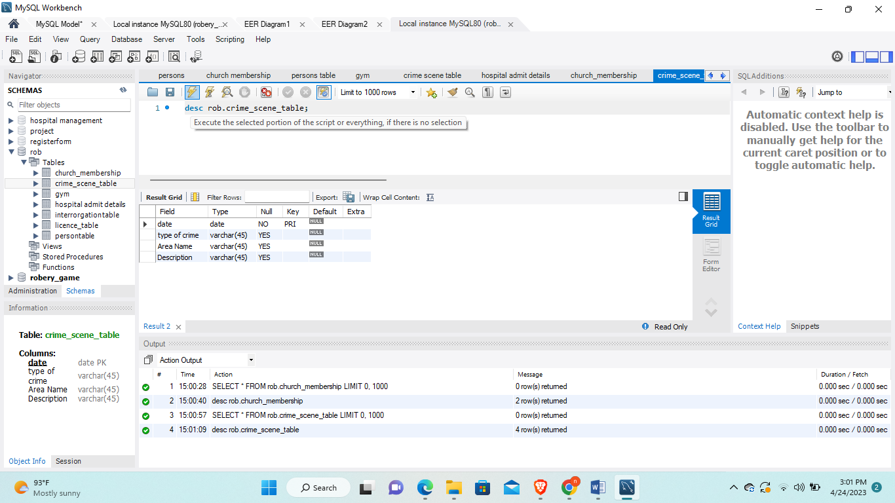

1. **Interrogation Table:**

The table contains details of the Statements that are given by the witnesses and accused.

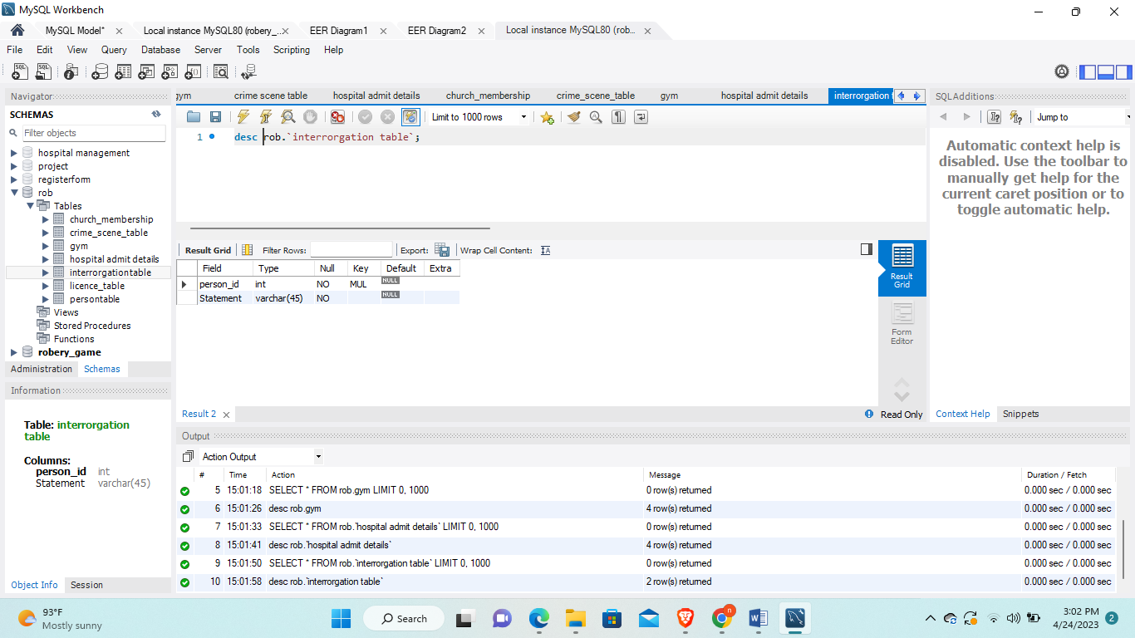

1. **Persons table:**

The Persons Table contains the details of every person lives in the Crime Reported Area.

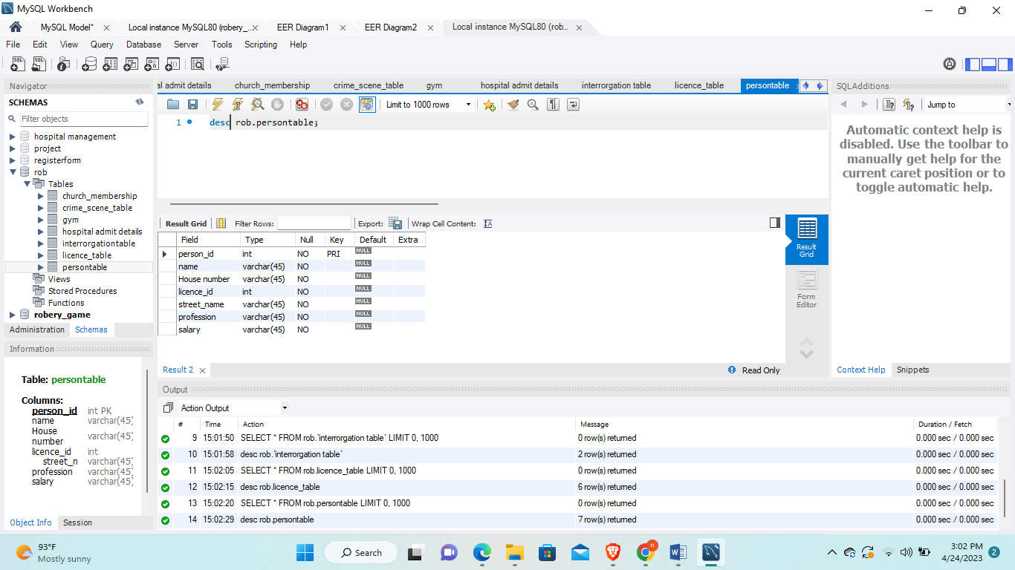

**4. License Table:**

The table contains the license information of the people along with their hair color and some physical appearances.

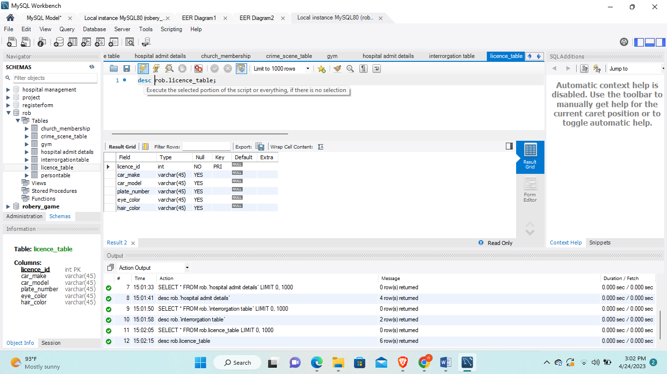

**5. Hospital Admission Details:**

This is the only hospital in the crime Scene area the details of the table will help the user to move forward in the game.

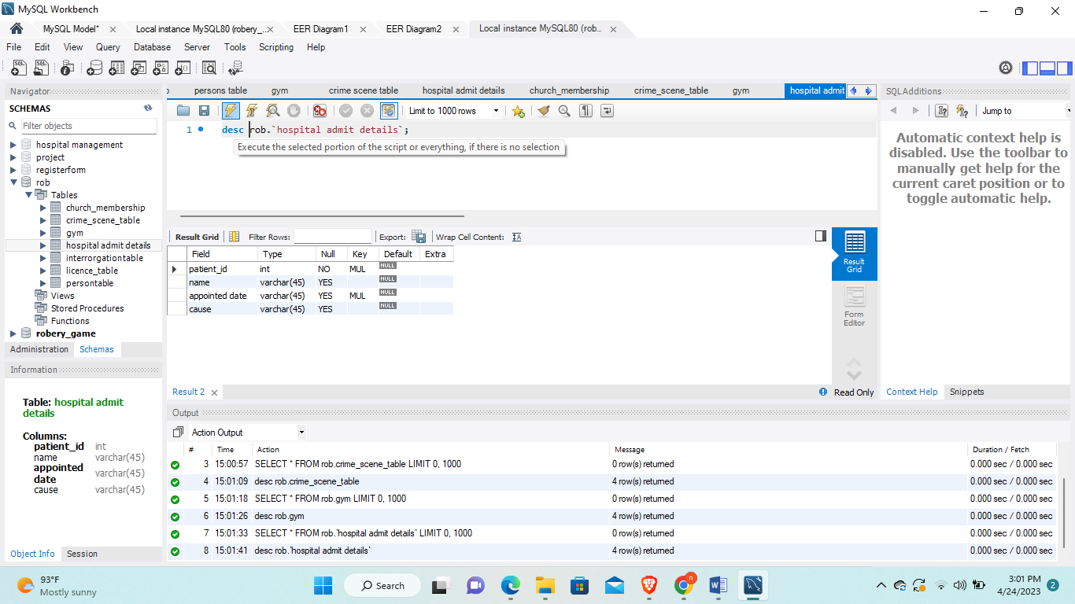

**6. Church Membership Details:**

This table contains the details of the members of the St.Lukes’s Church.

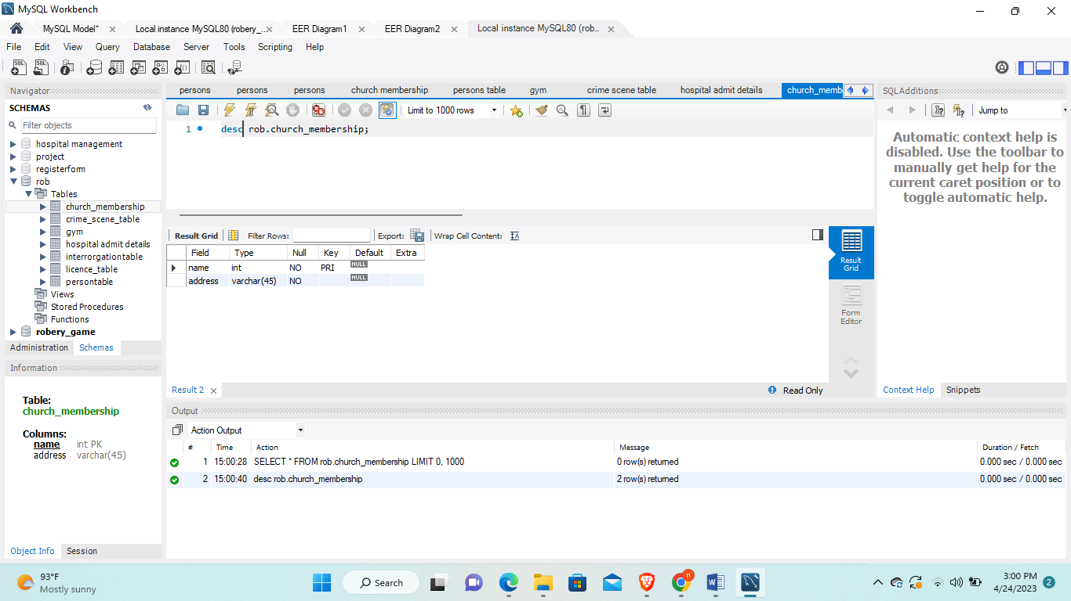

**7. Gym Membership Table:**

This Table Contains the Details of the people Work out in the gym .The table Structure is shown in figure.

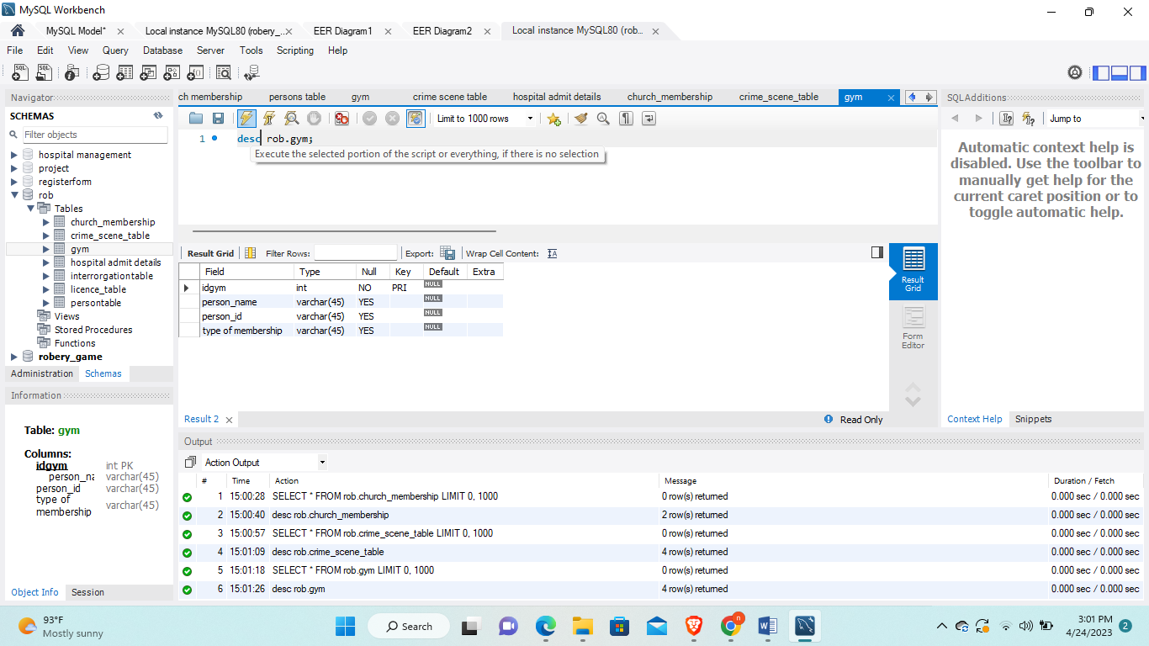

**E-R DIAGRAM:**

The Entity-Relation Diagram represents the Relation between the tables in the database.

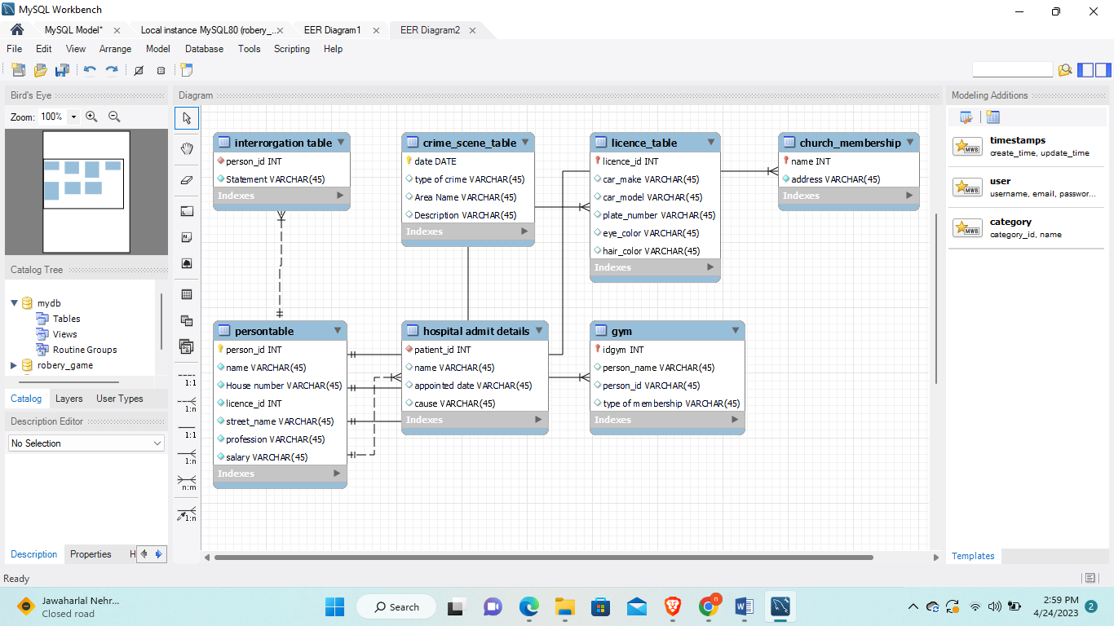

**CONCLUSION:**

The final Master Mind of the crime will be found by the user based on the hints and statements obtained in the process.